

DEPARTMENT OF COMPUTER SCIENCE & ENGINEERING
A Dissertation Report on
Alcatraz, an end-to-end SaaS product for complete computer and network security
-
Submitted by

Akash Gupta 1MS13CS014
Ayush Kumar 1MS13CS034
Bineet Kumar 1MS13CS036
Deepak Jayaprakash 1MS13CS037

in partial fulfillment for the award of the degree of

Bachelor of Engineering in Computer Science & Engineering
Under the guidance of

J Geetha Reddy
Assistant Professor
Department of Computer and Engineering
Ramaiah Institute of Technology

2016-2017 Batch
M.S.RAMAIAH INSTITUTE OF TECHNOLOGY
(Autonomous Institute, Affiliated to VTU)
BANGALORE-560054
www.msrit.edu

DEPARTMENT OF COMPUTER SCIENCE & ENGINEERING
CERTIFICATE

This is to certify that the project work titled Alcatraz, an end-to-end SaaS product for complete computer and network security is a bonafide work carried out by Akash Gupta 1MS13CS014, Ayush Kumar 1MS13CS034, Bineet Kumar 1MS13CS036 and Deepak Jayaprakash 1MS13CS037 in partial fulfillment for the award of degree of Bachelor of Engineering in Computer Science and Engineering during the year 2016-2017. The Project report has been approved as it satisfies the academic requirements with respect to the project work prescribed for Bachelor of Engineering Degree. To the best of our understanding the work submitted in this report has not been submitted, in part or full, for the award of said degree.

Signature of the Guide Signature of the HOD
J Geetha Reddy Dr. Anita Kanavalli

External Examiners
Name of the Examiners: Signature
1.
2.

M.S.RAMAIAH INSTITUTE OF TECHNOLOGY
(Autonomous Institute, Affiliated to VTU)
BANGALORE-560054
www.msrit.edu

DECLARATION

We students of final semester BE, Dept. of Computer Science and Engineering, Ramaiah Institute of Technology, Bangalore, hereby declare that the project entitled “Alcatraz, an end-to-end SaaS product for complete computer and network security”, thesis completed and written by us under the guidance of J Geetha Reddy, Dept of CSE, Bangalore for the partial fulfillment of the requirements for the award of the degree of Bachelor of Engineering has not been formed the basis for award of any other degree or diploma certificate.

Place:
Date:
Akash Gupta 1MS13CS014
Ayush Kumar 1MS13CS034
Bineet Kumar 1MS13CS036
Deepak Jayaprakash 1MS13CS037

ACKNOWLEDGEMENT

First and foremost, my utmost gratitude to J Geetha Reddy Department of CSE, MSRIT whose sincerity and encouragement we will never forget. She has been our inspiration as we overcame all the obstacles in the completion of this project work.

Dr. Anita Kanavalli, Head of the Department of Computer Science and Engineering, had kind concern and consideration regarding project work and we would like to thank her for continues support.

We would like to thank our beloved principal Dr. N.V.R Naidu for his support and encouragement.

This work would not have been possible without the guidance and help of several individuals who in one way or another contributed their valuable assistance in preparation and completion of this study.

We would like to express sincere thanks to all the teaching and non-teaching faculty of CSE Department and my dear friends who helped in all the ways while preparing the Report.

Abstract

The demand for modern tools and techniques to restrict access to applications and services which contain delicate data is increasing exponentially each year. Traditional methods such as PINs, tokens, or passwords fail to keep up with the challenges presented because they can be lost or stolen, which compromises the system security. But even the most powerful cryptographic systems fail to prevent unauthorized access.

Developers need to address the issue of security at each module while developing applications involving customer info. The aim of the project is to provide the basic features needed to make a system secure. Hence, we have services ranging from Biometric Authentication to Network Intrusion Detection Systems.

Here is a fairly detailed description of the services offered as a part of the product.
Keystroke Biometric Authentication: Biometrics are based on “who” is the person or “how” the person behaves, present a significant security advancement to meet these new challenges. The most promising approach has been Keystroke biometrics which refers to the habitual patterns or rhythms an individual exhibits while typing on a keyboard input device.

Network Intrusion Detection: In the era of information society, computer networks and their related applications are becoming more and more popular. Therefore, the role of Intrusion Detection Systems (IDSs), as special-purpose devices to detect anomalies and attacks in the network, is becoming more important.

Anti-Keylogging System: This feature enables a developer to enable a combination of encryption and hashing when important form data are to be transferred over the network.

Contents

Declaration i

Acknowledgements ii

Abstract iii

List of Figures

List of Tables

1 INTRODUCTION 1

  - General Introduction 1
  - Statement of the Problem 1
  - Objectives of the project 2
  - Project deliverables 2
  - Current Scope 3
  - Future Scope 3

- PROJECT ORGANIZATION 4
  - Software Process Models 4
  - Roles and Responsibilities 5

- LITERATURE SURVEY 6
3.1 Introduction 6
3.2 Related Works with the citation of the References 8
3.3 Conclusion of Survey 9

- PROJECT MANAGEMENT PLAN 10
  - Schedule of the Project (Represent it using Gantt Chart) 10
  - Risk Identification 12

- SOFTWARE REQUIREMENT SPECIFICATIONS 13
5.1 Product Overview 13
5.2 External Interface Requirements 13
5.2.1 User Interfaces 13
5.2.2 Software Interfaces 13
5.2.3 Communication Interfaces 13
5.3 Functional Requirements 14
5.4 Software System Attributes 15
5.4.1 Availability 15
5.4.2 Security 15
5.4.3 Portability 15
5.4.4 Maintainability 16
5.4.5 Performance 16
5.5 Performance Requirements 16
5.6 Design Constraints 16
5.7 Other Requirements 16

- DESIGN 17
  - Introduction 17
  - Architecture Design 19
  - Data flow diagram 21
  - Conclusion 23

- IMPLEMENTATION 24
  - Tools Introduction 24
  - Technology Introduction 24
  - Overall view of the project in terms of implementation 25
  - Explanation of Algorithm and how it is been implemented 25
  - Information about the implementation of Modules 26
  - Conclusion 26

- TESTING 27
  - Introduction 27
  - Testing Environment 27
  - Test cases 27
  - Types of testing performed 29
  - Conclusion 30

- CONCLUSION & SCOPE FOR FUTURE WORK 31
- REFERENCES 32
- Appendix 34
- Software manual (if required in the project)
- Screen snapshots

LIST OF FIGURES

Sl.  No. | Figure No. | Figure Name | Page No.
1 | Figure 2.1 | Agile Model | 2
2 | Figure 3.1 | Keystroke Model | 6
3 | Figure 4.1 | Planning & SRS | 9
4 | Figure 4.2 | Keystroke Timeline | 9
5 | Figure 4.3 | Network Intrusion Detection timeline | 10
6 | Figure 4.4 | Anti-Key Logging timeline | 10
7 | Figure 4.5 | Secure Mail Transfer timeline | 10
8 | Figure 6.1 | UI Landing Page | 17
9 | Figure 6.2 | UI for Network Intrusion Detection | 18
10 | Figure 6.3 | Directory Structure | 18
11 | Figure 6.4 | ML scripts for Keystroke Authentication | 19
12 | Figure 6.5 | DM Classifier | 19
13 | Figure 6.6 | Architecture for Keystroke Authentication | 20
14 | Figure 6.7 | Architecture for Network Intrusion Detection | 20
15 | Figure 6.8 | State Diagram Network Intrusion Detection | 21
16 | Figure 6.9 | Data flow diagram of Keystroke Authentication | 22
17 | Figure 6.10 | Data flow diagram of Network Intrusion Detection | 23
18 | Figure 8.1 | Types of Testing | 29

LIST OF TABLES

Sl. No. | Table No. | Table Name | Page No.
1 | Table 2.1 | Roles and Responsibilities | 5
2 | Table 4.1 | Risk Identification and Mitigation | 12

CHAPTER 1

1. INTRODUCTION

1.1 General Introduction
Developers need to address the issue of security at each module while developing applications involving customer information. The aim of the project is to provide the basic features needed to make a system secure. Hence, we have services ranging from Biometric Authentication to Network Intrusion Detection Systems.
Biometrics, defined as the physical traits and behavioral characteristics that make each of us unique, are a natural choice for identity verification.
In the era of information society, computer networks and their related applications are becoming more and more popular, so does the potential threat to the global information infrastructure to increase. Therefore, the role of Intrusion Detection Systems (IDSs), as special-purpose devices to detect anomalies and attacks in the network, is becoming more important.
Keyloggers are a type of activity-monitoring software that is installed on your computer without your knowledge. The most common ways of doing this are through phishing, social engineering, bundling the keylogger with other software or downloads on file-sharing sites or installing it when you open an email attachment

1.2 Statement of the Problem
The product is developed as a part of the final year project. It is aimed at providing an architecture and open source code to developers so that they can embed these features into their applications to enhance the security. The services provided are top notch and cover the broad spectrum of computer and network security. All the features of the product involve the application of Data Mining and Machine Learning techniques onto the domain of Computer Security.
The most prominent features of the product (as of now) include Keystroke Biometric Authentication, Network Intrusion Detection, Privacy respecting Cloud, Secure File/Mail transfer, etc.

1.3 Objectives of the project
The project is primarily aimed at providing complete web based security without having to download any external software. The objective is to provide a source of reference for open source developers so that they can use the code in their applications and to motivate young coders to also concentrate on Computer and Network Security while developing web applications. We have used NSL-KDD data set to analyze and study the effectiveness of the various classification algorithms in detecting the anomalies in the network traffic patterns. We have also analyzed the relationship of the attributes available in the commonly used network protocol stack with the attacks used by intruders to generate anomalous network traffic. The project also aims at removing the redundancies before construction of models. This avoids the over fitting of data which would result in biased results.
And there are other features like Biometric Keystroke Authentication and Anti-Key Logging which provide the direct security the user.
To summarize, we aim at providing a SaaS architecture and an open source tool which developers can integrate easily with their web applications.

1.4 Project deliverables
The deliverables are specific to each feature. Below is a brief summary of the list of deliverables which spans across the entire project as a whole.
- Open source code for the developers so that they can embed this onto the existing applications.
- Features offered can be installed and used over the web without a need to download any external software
- Module wise split up and detailed explanation of all the Data Mining and Machine Learning algorithms used.
- Use of Seasoned Version Control Systems to track the contribution of open source developers
- Accuracy comparison of different statistical models built.

1.5 Current Scope
The product is able to provide full web application security. Different features of the product provide extensive security solutions based on the keystrokes and also provide other way to avoid any cross side scripting by providing features like Anti-key logging. The network side of the security is also offered as a feature, called as Network Intrusion Detection which in brief lets the user know if the query in the network traffic is a normal one or an attack. Apart from these, a fully documented 3rd party authentication system called A-Auth has been built. The authentication mechanism is a simplified version of the popular O-Auth authentication protocol.
As a whole, the project is hosted as an open source project which is ready to be released as a version. The documentation is apt and precise which makes it a perfect place for open source developers to contribute.

1.6 Future Scope
The features are completely working, but the cohesion between the modules can be improved further. The models built work over individual ML/DM algorithms but they do not interact and communicate with each other to come up with an overall optimized result. Therefore an ensemble learning algorithm can be developed to provide a bootstrapped result which would be a culmination of all the models built. Ensemble models usually are more accurate, robust and adaptable. All the analysis and algorithms are built offline and are passive to online traffic. Real-time analysis of network data could be added to Network Intrusion Detection to make this product more effective.

The ML algorithms built can be improved by enabling Reinforced Learning. This improves not just the accuracy but also makes the models more adaptive.

CHAPTER 2

2. PROJECT ORGANIZATION

2.1 Software Process Models
The project model that we have adapted is the Agile Development Methodology. “Agile Development” is an umbrella term for several iterative and incremental software development methodologies. The most popular agile methodologies include Extreme Programming (XP), Scrum, Crystal, Dynamic Systems Development Method (DSDM), Lean Development, and Feature-Driven Development (FDD).

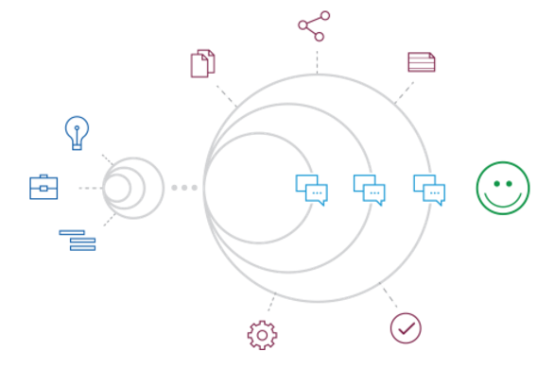
Fig 2.1: Agile Development Methodology

We have used Extreme Programming (XP) in our project because of the suitability of the product requirements and the similarity in its implementation. XP has emerged as one of the most popular and controversial agile methodologies. XP is a disciplined approach to delivering high-quality software quickly and continuously. It promotes high customer involvement, rapid feedback loops, continuous testing, continuous planning, and close teamwork to deliver working software at very frequent intervals, typically every 1-3 weeks.

The principles that have been used with regard to XP in the project are:
- Planning architecture, tech stack, implementation, etc.
- Small releases
- User acceptance tests
- Simple Design
- Pair programming
- Test driven development
- Refactoring
- Continuous Integration
- Coding standards

2.2 Roles and Responsibilities
Roles | Assigned To
Keystroke R models and Interfacing | Ayush , Bineet
Network Intrusion Detection | Akash , Deepak
Anti-Key Login | Deepak, Ayush
A_Auth | Bineet, Deepak

Table 2.1 Roles and Responsibilities

CHAPTER 3

3. LITERATURE SURVEY

3.1 Introduction
Each feature of the product is a topic of research and development itself, the literature survey is specified with respect to a feature wise split of the product. We would start with Keystroke Biometrics and list the survey according to importance of the work and time of publication.
Keystroke Dynamics has become a widely researched and active area due to the increasing importance of cyber security and computer or network access control. Most of the existing approaches focus on static verification, where a user types specific pre-enrolled string, e.g., a password during a login process, and then their keystroke features are analyzed for authentication purposes [10]. Only a few research studies address the more challenging problem of keystroke biometrics using “free text”, where the users can type arbitrary text as input. Keystroke dynamics features are usually extracted using the timing information of the key down/hold/up events. The hold time or dwell time of individual keys, and the latency between two keys, i.e., the time interval between the release of a key and the pressing of the next key are typically exploited.
The features extracted from keystroke dynamics pattern in most of researches are timing features. Fig shows the extracted timing features:
1. Key Hold (KD): key delay between pressed and key released.
2. Down-Down Key Latency (DDKL): time in between two consecutive presses.
3. Up-Up Key Latency (UUKL): time between two successive releases.
4. Up-Down Key Latency (UDKL): time in between the current key release and the next key press.
5. Down-Up Key Latency (DUKL): time between the current key press and the next key release.

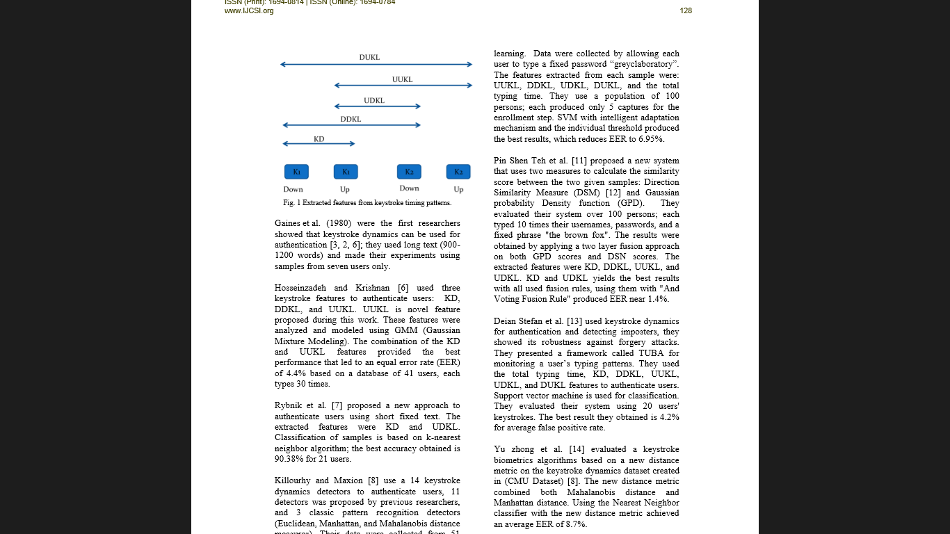
Fig 3.1: Keystroke timing features

Research work on keystroke dynamics all originated from Gaines et al. [16] who did a preliminary study authentication using the T-test on digraph features.
Monrose and Rubin few years later extracted keystroke features using the mean and variance of both digraphs and trigraphs. Then there were statistical Euclidean distance metrics with Bayesian-like classifiers identified 92% for their small dataset containing 63 users correctly. Over the years, keystroke biometrics research has been implemented in many existing machine learning algorithms and classification techniques.

Researchers have presented their work on choosing different distance metrics, such as the Euclidean distance, the Mahalanobis distance and the Manhattan distance and have been explored their suitability on the biometrc authentication. For the implementation both classical and advanced classifiers have been used, including K-Nearest Neighbours (KNN) classifiers [4], Bayesian classifiers, K means methods [12], Fuzzy logic, neural networks , and support vector machines (SVMs). A promising research effort in applying keystroke dynamics as a static authentication method originated from the work of Joyce and Gupta [15]. Their approach is relatively simple and yields impressive results.

The NSL-KDD data set is the refined version of the KDD cup99 data set. The original DARPA data set is not used because of a number of prominent reasons. The first important deficiency in the KDD data set is the huge number of redundant records. The existence of these repeated records in the test set, on the other hand, will cause the evaluation results to be biased. Another problem is that the models built over fit the data due to which it cannot identify any new attacks that occur.

3.2 Related Works
Prominent data mining algorithms like Naïve Bayes, Decision Tree, K-nearest neighbor, K-Means and Fuzzy C-Mean clustering algorithms and machine learning strategies like Support Vector Machine (SVM), neural nets have been applied to study the classification.

The entire research can be classified into:
- Machine Learning Based IDS: Naïve Bayes, KNN, SVM and the proposed method multi Objective Genetic Fuzzy Intrusion Detection System (MOGFIDS), etc. Systems have been proposed that makes use of the analytical strengths of neural networks to detect stepping-stone intrusion with two schemes. Among the two schemes, one uses eight packet variables and the other clusters a sequence of consecutive packet in round-trip times.

- The Multiple Classifiers (MCS) approach was suggested based on pattern recognition distinct feature representation and tested with different fusion rules (Giorgio Giacinto et al 2003). The reported results proved that the MCS approach provides a better false alarm generation than that provided by an individual classifier trained on the overall feature set. Among the fusion rules, the dynamic classifier selection technique provided the best results.

- Boosting based IDS: Boosting is a method to develop the accuracy of several given learning algorithms by combining weak classifiers to get one strong classifier. Weiming Hu et al (2008) suggested an Adaboost based intrusion detection algorithm, in which the decision stumps are used as weak classifiers and the decision rules are provided for both categorical and continuous features. Jun Gao et al (2009) presented a distributed IDS framework based on the Model based online Adaboost algorithm and Particle Swarm Optimization-SVM algorithm.

- Data Mining and Rule based IDS: In data mining approaches, IDS comprises association rules and recurrent episodes, which are based on constructing classifiers by discovering appropriate patterns of program and user performance. The association rules and frequent episodes are used to study the patterns that illustrate user behavior.

- Anti-Keylogging System is a type of activity-monitoring software that is installed on your computer without your knowledge. The most common ways of doing this are through phishing, social engineering, bundling the keylogger with other software or downloads on file-sharing sites or installing it when you open an email attachment. The research done on this include: behavior based detection technique using KLIMAX: Kernel- Level Infrastructure for Memory and execution profiling.[17], [18], [19]. The first primary target of the keylogger is to secretly record confidential information of user’s input through keystroke monitoring and then relaying this valuable information to others.

Therefore, an attacker can simply retrieve and access important information with the help of logging keystrokes. Generally, there is no intelligence built-in keylogger, but logs offer information about every single keyboard event and applications that users clicked or typed.

The stealthy keylogger cannot be detected by many Anti-viruses software as running on the victim’s machine. The user has no way to determine the presence of keylogger on his machine, therefore, he turn into a victim of the identity theft.

3.3 Conclusion of Survey
We were able to discover that many other models are able to authenticate in case of Keystroke Authentication and predict in case of NID with certain level of accuracy, and by applying other models and manipulate the existing modules we may be able to achieve an accuracy much higher than the existing work.

CHAPTER 4

4. PROJECT MANAGEMENT PLAN

4.1 Schedule of the Project


Fig 4.1: Planning and SRS


Fig 4.2: Keystroke Biometric Authentication

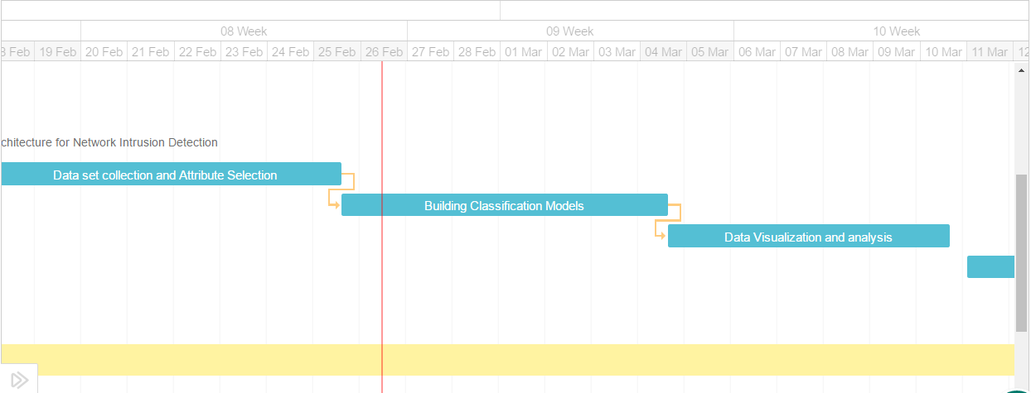
Fig 4.3: Network Intrusion Detection

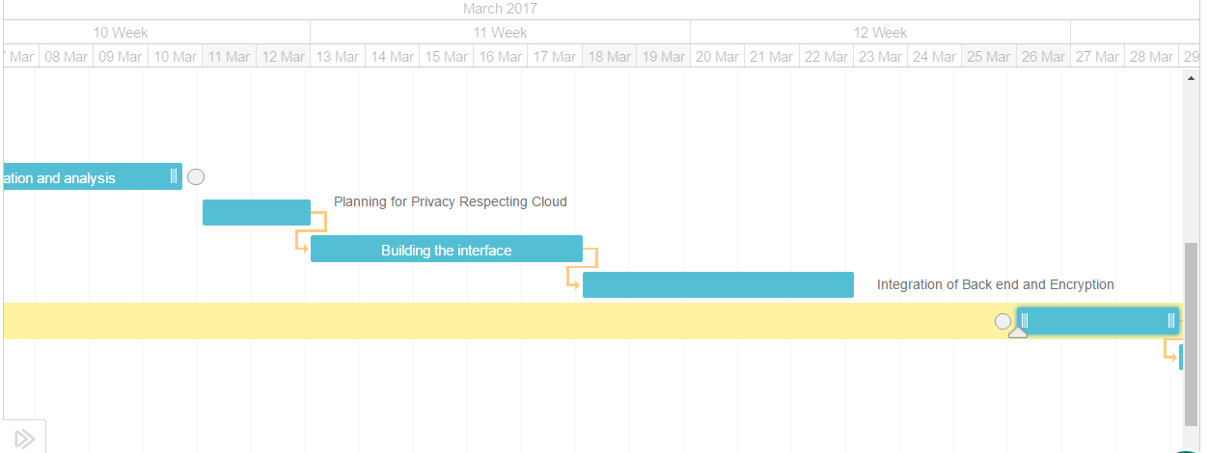
Fig 4.4: Anti-Key login


Fig 4.5: Secure Mail Transfer and Documentation

4.2 Risk Identification
Sl.No | Risk | Point of source | Mitigation Strategy
1 | Scope Creep: Scope of the project may keep increasing if it is not accounted in each phase. | Project Planning | Accountability of the scope and proper documentation
2 | Wrong Design : Directly implementing a solution without considering alternatives can result in a poor product. | Architecture planning and Design | Time must be spent in understanding the problem statement and a proper design methodology must be chosen.
3 | Improper handling of threads :  While using asynchronous functions, threads using multiple functions must be taken care of race conditions, mutual exclusion and critical section. | Development and implementation | Proper thread handling/calling APIs should be used and a design paradigm like master/slave architecture can be chosen.
4 | Modules not clearly defined :  Since the modules are reused in the software, the modules definitions, functionality and behavior must be defined clearly. | Design and Development. | Proper Object Oriented programming techniques must be used to properly define the behaviur of the module.
Table 4.1: Risk Identification and Mitigation
CHAPTER 5
5. SOFTWARE REQUIREMENT SPECIFICATION
5.1 Product Overview
Several protective measures such as firewall have been put in place to check the activities of intruders which could not guarantee the full protection of the system. Hence, the need for a more dynamic mechanisms likeBiometrics and intrusion detection system (IDS) as a second line of defense. Intrusion detection is the process of monitoring events occurring in a computer system or network and analyzing them for signs of intrusions [1 The two different detection techniques employed in IDS to search for attack patterns are Misuse and Anomaly. Misuse detection systems find known attack signatures in the monitored resources. Anomaly detection systems find attacks by detecting changes in the pattern of utilization or bahaviour of the system

5.2 External Interface Requirements
5.2.1 User Interfaces
The interface used to build the project is R Studio. The choice was not very complex. It comes with a data set Viewer, workspace manager, a plot viewer, and all the work can be undone, redone and saved at regular intervals. It works pretty fast on a PC with an average processor speed.

5.2.2 Software Interfaces
The software was R 3.2.5. Note the version is important because the data mining libraries like caret, naivebayes, ggplot2, plotly, decisiontree are not available in the older versions. The standard R.exe file can be downloaded from the official cran website. The choice of language was not a hard one. It’s really difficult to construct models from the scratch and vary the parameters like we do in R. Hence, a lot of pre processing and plotting functions can be easily done in R.

5.2.3 Communication Interfaces
The project as of now does not need any communication interface but the extension needs a
packet capture software like WireShark, etc. Besides, the network traffic was captured using
a communication interface itself.
5.3 Functional Requirements

1. Portal to capture the keystrokes from the user and to train the model.
2. A database to store the keystroke parameters of all registered users and other credentials.
3. A detailed description of the data and its attributes for Network Intrusion Detection.
4. Testing suite for measuring and comparing the accuracy of the models built.
5. A visualization set of libraries for complete data visualization

5.4 Software System Attributes
5.4.1 Availability
All the requirements used in the project is available in public repositories. The data set released by both DARPA and NSL-KDD are too public. The project itself uses all the libraries in the cran studio. The research task requires various ground truth databases in its region and the experimentation would be completed effectively if the quality and features of data for the specific region are good. Image processing, web site analysis, medical applications, remote sensing, etc. have standard and authorized ground truth databases for analysis. Likewise, most of the computer network intrusion detection systems use the KDD Cup99 for the classification analysis of network traffic.

5.4.2 Security
Intrusion detection system is a remarkable component in securing information systems and also an impressive security technology, which can detect, prevent and possibly react to the attacks in an efficient manner by inspecting network data. It is made up of many methods which are formed and activated to find system intrusions. The intrusion prevention activities include writing outstanding protection programs by implementing the organization policies. Although many intrusion detection techniques are used to detect the existing types of attacks within the network infrastructure, reducing false positive and false negative is still a major issue. But most of existing intrusion detection system give high false alarm rates and fail to detect many attacks because of a deficiency in their ability to discriminate attacks from legitimate behaviors.

5.4.3 Portability
All the intrusion detection systems are Operating System independent. At any point of time a web server can be visited by many clients and they naturally produce heavy traffic. Each network connection can be visualized as a set of attributes. The traffic data can be logged and be used to study and classify in to normal and abnormal traffic. In order to process the voluminous database, machine learning techniques can be used. Therefore the project is portable onto any Operating System which has R installed in it.

5.4.4 Maintainability
The project requires no maintenance as such in some cases, if any untrained attack happens off then sometimes the system will crash. But some models like Naïve Bayes will still work since it’s a mathematical model.

5.4.5 Performance
The performance in the current project can e defined in terms of accuracy and time taken to build the model and test the data. We have come up with different combinations and in each of the trial the time taken and the accuracy is noted down.

5.5 Performance Requirements
5.5.1 Real-Time:
The project meets the real time benchmarks with respect to coding standards and time taken to build the learning models. It is developed as per the global standards of Object-Oriented-Paradigm using accepted design patterns and technology stack.

5.5.2 System Resource Consumption:
Some of the modules involve a lot of processing and CPU utilization. Therefore minimal requirement is that the server should have some compute power. The algorithms are efficient in terms of complexities of time and space.

5.6 Design Constraints
The design constraints that will affect the design of this application are the
- Schedule and the performance
The project must be completed on schedule and the performance of the application must
be very high and also changes made to the existing framework should as minimum as possible.
- High Dynamic Range Noise Reduction Method
When user enables this method, design should be such that it takes care of acquiring data and posting results for each iteration of each segments.

5.7 Other Requirements
Other software interfaces like Apache Tomcat, XAMMP server and MySQL database

CHAPTER 6
6. SYSTEM DESIGN
6.1 Introduction
6.1.1 Description of the organization of the document
The design document is an overall guide, more of a release notes to the entire product. It contains some detailed description of each feature split module-wise. To make it easy for the end user, the document is organized feature wise so that any developer can only research about the product he/she is interested in, without bothering about the rest of the features.

As the product doesn’t follow the typical object oriented paradigm, there exists no class diagrams, instead there are some sequence diagrams, data flow diagrams, etc.

6.1.2 Number of Module
The total number of modules in the entire project is 5. The project has a good module wise split up which increases the cohesion.

6.1.3 Modules description
The module explanation is given below feature-wise.

      - UI Module: This involves the use of front end tech like Bootstrap, jQuery and CSS3. The features include a rich Dashboard for Keystroke demo and also graphs and output classification for Intrusion Detection.
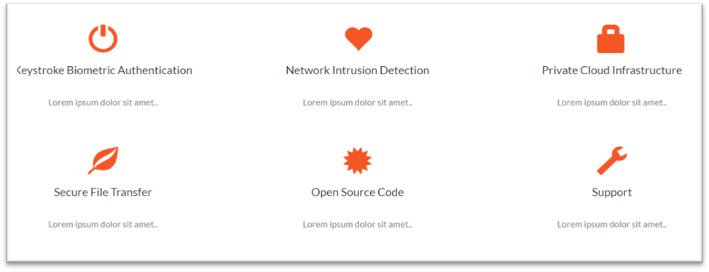
Fig 6.1: UI landing page

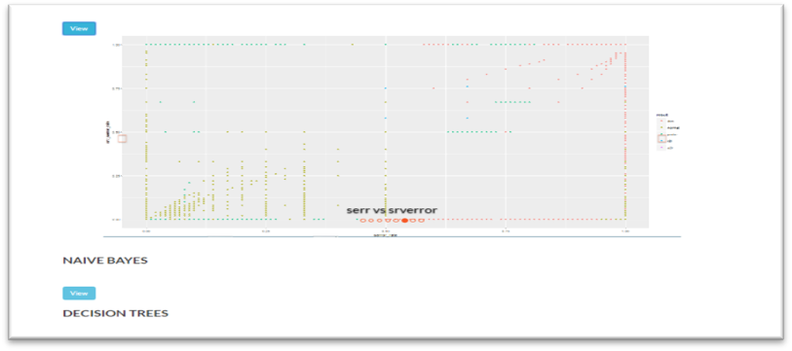

Fig 6.2: UI for IDS

      - Back end scripts: After the front end validations and inputs are taken from the user, the data is passed onto the server by using PHP scripts.
In the directory structure shown here, scripts like checklogin.php, logout.php, print.php, profile.php, register.php, validate.php are the backend scripts.

Fig 6.3: Directory structure

6.1.3.3 Machine Learning scripts: The rscripts used for the classification are the machine learning algorithms embedded onto it. These are the 3 classifiers used in Keystroke Authentication.


Fig 6.4 ML scripts for Keystroke Authentication

      - Databases: The database used is MySql and is used in conjugation with PHP. The db is used to maintain user accounts and profile information. Along with the db, csv files are edited repeatedly after making front-end JS validations to store some information like keystroke timings, etc

      - Data mining algorithm module: The DM algorithms are the classifiers used in NID. The files are as shown below, the steps involved here are selection of attributes, labeling them, building the modules and visualization.

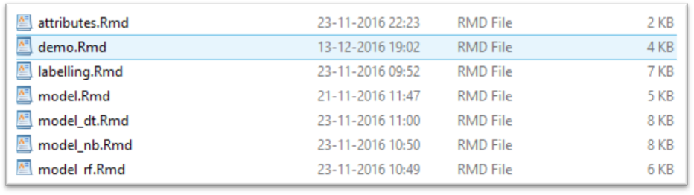
Fig 6.5: DM classifiers

6.2 Architecture Design
The architecture for features are as shown below

6.2.1 Keystroke Authentication:
The problem with the existing work and implementations related to keystroke authentication based on static text is that the statistic chosen and the model built are not very accessible and compatible with each other. Therefore we propose an easier and a much simpler model and metric to achieve the desired classification which has better interpretability as shown in Fig 6.6.
The whole model can be divided four distinct steps. These are listed as follows:
- The individual register their name and password with the database. Then the user has to type his username and train the machine for six times.
- Features are extracted when individuals press and release keys. More specifically the delay between the key-down and key-up time.
- The algorithm is applied and the threshold is generated based on the variations that the user has done while typing the 6 training set. Hence, the adaptiveness.
- Calculate the Euclidean distance between training and the test samples to get the user's score.
- Finally, the user's score is compared against its threshold to make the decision. If the Euclidean measure generated from the test sample is too high when compared to the training set then the user is classified to be an imposter.

Some key milestones in the architecture:
- Data and feature extraction
- Metric selection: Manhattan/Mahalononobis/ Euclidean
- Decision Making
- Verification
- Accuracy Analysis
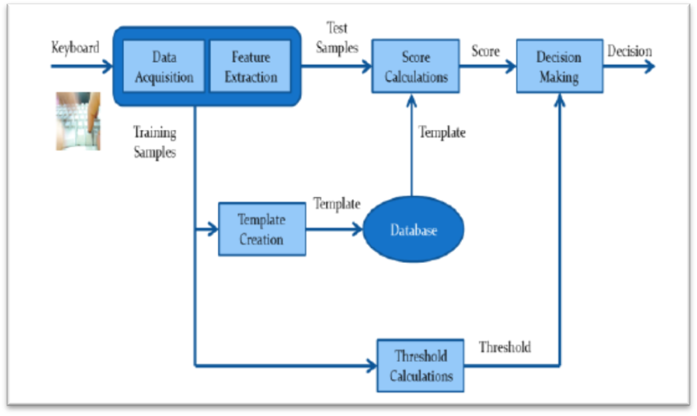
Fig 6.6: Architecture for Keystroke Authentication

    - Network Intrusion Detection:

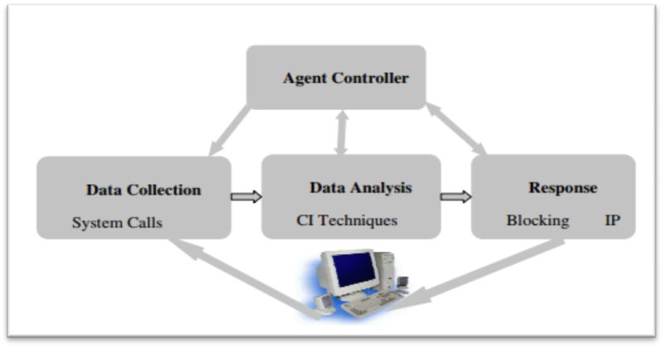
Fig 6.7: Architecture design of an NID

Majority of the IDS currently in use are either rule-based or expert-system based. Their strengths depend largely on the ability of the security personnel that develops them. The former can only detect known attack types and the latter is prone to generation of false positive alarms.
This leads to the use of an intelligence technique known as data mining/machine learning technique as an alternative to expensive and strenuous human input. These techniques automatically learn from data or extract useful pattern from data as a reference for normal/attack traffic behavior profile from existing data for subsequent classification of network traffic. Identification of important features is one of the major factors determining the success of any learning algorithm on a given task. Feature selection in learning process leads to reduction in computational cost, over fitting, model size and leads to increase in accuracy.

  - Data Flow Diagram

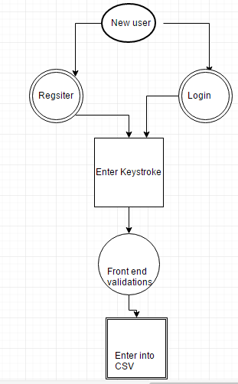
Fig 6.8: Keystroke Authentication registration State diagram

Fig 6.8 explains the flow when a user enters to the portal for the first time. New users are made to register with a username and a password, which is used to train the machine later on. After they register, they are made to enter the keystroke pattern and record it.
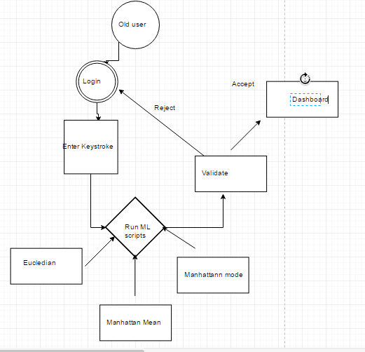
Fig 6.9: Keystroke Authentication ML Data Flow Diagram

Fig 6.9 shows the application of Machine Learning process in the Keystroke Authentication module. The models are built and the result is passed onto the validator. The threshold for the classification is either dynamic or fixed based on the type of model. Then depending upon the threshold, the user is allowed to access.

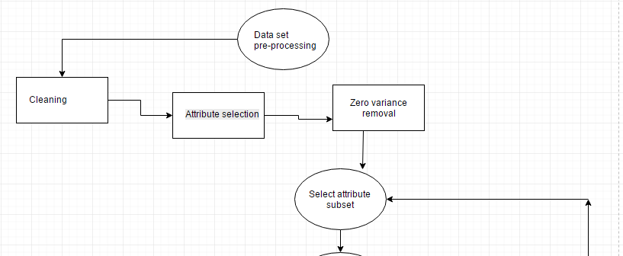
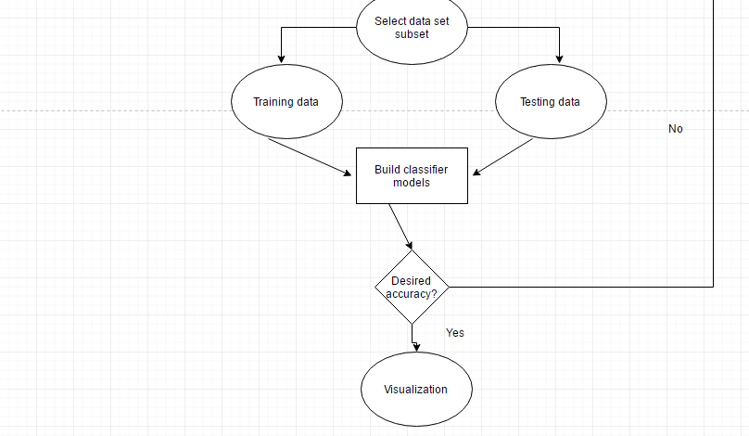
Fig 6.10 Network Intrusion Detection Data Flow Diagram

Fig 6.10 shows the overall architectural design of NID. It starts from Pre-processing, Attribute selection and then splits the data. The ratio of division of the data set into training and testing is based on the classification model and the combination of number of attributes and size of training data. The models are built and the classifications are compared against the tested results. Then, if the desired accuracy is reached, visualization phase is started, else, different combination of parameters are taken and the models are rebuilt again.

CHAPTER 7

7. IMPLEMENTATION

7.1 Tools Introduction
7.1.1 R Studio
R is a powerful language and environment for statistical computing and graphics. It is a public domain (a so called “GNU”) project which is similar to the commercial S language and environment which was developed at Bell Laboratories (for merly AT&T, now Lucent Technologies) by John Chambers and colleagues. R can be considered as a different implementation of S, and is much used in as an educational language and research tool. The main advantages of R are the fact that R is freeware and that there is a lot of help available online. It is quite similar to other programming packages such as MatLab (not freeware), but more user-friendly than programming languages such as C++ or Fortran. You can use R as it is, but for educational purposes we prefer to use R in combination with the RStudio interface (also freeware), which has an organized layout and several extra options.

7.1.2 XAMPP
It is a simple, lightweight Apache distribution that makes it extremely easy for developers to create a local web server for testing and deployment purposes. Everything needed to set up a web server – server application (Apache), database (MariaDB), and scripting language (PHP) – is included in an extractable file. XAMPP is also cross-platform, which means it works equally well on Linux, Mac and Windows. Since most actual web server deployments use the same components as XAMPP, it makes transitioning from a local test server to a live server extremely easy as well.

7.2 Technology Introduction

Using the design described in the above section the experiment software was successfully built, tested and used to gather data. Rather than give an in-depth analysis of the code, we shall provide an more informative overview of the technologies we used, and describe the interaction with the software that volunteers experienced. We built the experiment software as a web application using the following technologies:

1. Front end: HTML 5, jQuery, Bootstrap for the creation of forms to accept the data from the user

2. JavaScript: To perform the front end validations and also to gather the key up time from the user

3. Ajax: To parse the timing data from the frontend JavaScript to the PHP

4. PHP: To perform all the file operations and IO

5. R: To build the model and to calculate the threshold.

6. MySql: To store the user id’s and the passwords and to maintain session information

7.3 Overall view of the project in terms of implementation

R is a strong language used in both features we implemented.
PHP and JS is used the capture keystrokes and also for anti-key login
All data analysis is done in R.

7.4 Explanation of Algorithm and how it is been implemented

7.4.2 The algorithm for dynamic thresholding

The threshold calculation is what makes the model adaptive and different than other existing models and algorithms. The window for error is the space in which he is permitted to cause any errors. This is decided by a method called Leave One-Out-Method (LOOM). This method is explained below in some detail in steps:
1. Out of the n samples, divide the training space of (n) samples to one sample used as test sample, and (n-1) samples used to create the training sample.
2. Apply a distance measure (Euclidean in our model) to calculate the distance between the selected test sample and the mean vector of the (n-1) training samples.
3. Iterate the step 2 for (n) times to produce (n) different thresholds for each feature vector.
4. The average of these (n) thresholds is calculated to produce the one single threshold that would represent the effective measure of all the thresholds in total.
5. These steps are repeated to calculate the individual thresholds for the other three distance measures.

7.2.3 Algorithm for Anti Key Logging

1. The client side forms and applications are embedded with an attribute called form_name.
2. The form elements along with this attribute is sent to the antikey.php which finds out whether this page needs to be encrypted or not.
3. If the page does not need anti key-logging usual flow is proceeded.
4. Now the parameters are encrypted using the AES encryption algorithm.
5. The key has to be generated dynamically so that any XSS attempt is a failure.
6. Hence, we use a hash function to generate a dynamic hash. To make it dynamic we use the parameters entered by the user itself.
7. In OAuth terms a GET request is sent to the server, with a [client_id, {subset of form elements}]. The server has a has function which replies with a hash code.
8. This hashCode is now used as the encryption key and then the form elements are sent to the destination page

7.2.4 Algorithm and work flow for Network Intrusion Detection

      - Setting up workspace and data

The NSL-KDD has a total size of 125000 tuples when compared to the original KDD set which had around 250000 tuples in the 20%subset. The IDE used is R Studio and the classifier models and algorithms are implemented in R as it is easier to analyze and compare the results and do pre-processing
      - Pre-processing and Attribute selection step

The only preprocessing step was to label the attacks into 4 main classes and also to normalize some of the attributes to the range of 0-1. The attribute selection is the tricky part. Typical models like random forests, decision trees, etc take very long time to build the model. Hence, the number of attributes must be reduced. Moreover, there are many zero variance features which are removed in this step.

      - Building the classifier and testing the results

Three algorithms were used to build the classifier models and each different combinations of number of attributes and the size of training set was used to analyze and compare the efficiencies. The following are the models built and a brief description
- Naïve Bayes

This model is based on conditional probability calculations and hence is a mathematical model. The maximum efficiency was obtained when 23 attributes and 125974 training and 25974 testing was used.
- Random Forest

Random Forests are a group of decision trees built by taking a particular subset of attributes or tuples as input for each tree. Then it uses a bagging and bootstrapping algorithm to ensemble the results obtained. The maximum efficiency was obtained when 23 attributes and 125974 training and 25974 testing was used.
- Decision Tree

It evaluates feature subsets using best-first search and can use cross-validation for evaluation. The order of attributes and the weight are decided by the algorithm itself.

The maximum efficiency was obtained when 8 attributes and 100000 training and 25974 testing was used.

7.6 Conclusion
The product using a wide range web application tools and data analytics tool to perform and provide security on all levels of the web application.

CHAPTER 8

8. TESTING

8.1 Introduction
Software testing is a process of executing a program or application with the intent of finding the software bugs. It can also be stated as the process of validating and verifying that a software program or application or product meets the business and technical requirements that guided its design and development.

Unit Testing
The primary goal of unit testing is to take the smallest piece of testable software in the application, isolate it from the remainder of the code, and determine whether it behaves exactly as you expect. Typically it is done by the programmer and not by testers, as it requires detailed knowledge of the internal program design and code.
Unit Testing Techniques:-
- Local data structures: These are tested to inquiry if the local data within the module is stored properly or not.
- Independent paths: All independent paths are tested to see that they are properly executing their task and terminating at the end of the program.
- Error handling paths: These are tested to review if errors are handled properly by them or not.
Integration Testing
In Integration Testing, many unit tested modules are combined into subsystems, which are then tested. The goal here is to see if the modules can be integrated properly.
Regression Testing-
Regression Testing is done when some changes are made to an existing system. When modifications are made to an existing system, testing also has to be done to make sure that the modification has not had any undesired side effect of making some of the earlier services faulty.

Performance Testing
Performance testing is the process of determining the speed or effectiveness of a software program. It can also serve to investigate, measure, validate or verify other quality attributes of the system, such as scalability, reliability and resource usage.
Load testing - It is the simplest form of testing conducted to understand the behavior of the system under a specific load.

8.2 Testing Environment
The project requires specific hardware and software components for its functioning. The testing process involves unit testing, integration testing and system testing of the log analyzer. Specific setup is required for the different types of testing. Testing was done on a DELL Precision desktop, connected to a power supply with the following specifications:
Hardware Specifications for I/O Trace and Build System:
- Intel ® Core i5 ™ CPU
- 4 GB RAM
- 64 bit OS
- 50 GB HDD
Software Specifications for I/O Trace and Build System:
- Windows 10 (64-bit)
- R 3.3.3
8.3 Test Cases
8.3.1 Biometric Keystroke Authentication
Test Case | Total number of test cases | Number of cases passed | Number of cases failed | Reasons for failure
Registering new users | 86 | 80 | 6 | Database error, exception handling
Entering keystrokes | 480 | 400 | 80 | Backspaces, improper typing pattern
Prediction | 86 | 82 | 4 | NA values not removed
Login | 86 | 84 | 2 | Storage of access pairs

8.3.2 Network Intrusion Detection
8.3.2.1 Decision Tree testing and accuracy analysis
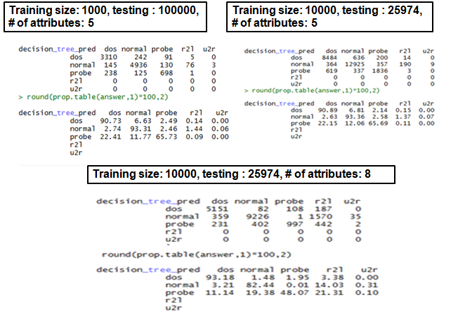

8.3.2.2 Naïve Bayes testing and accuracy analysis
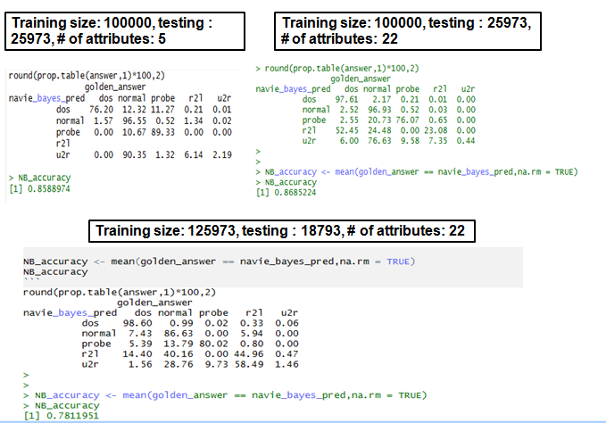
8.3.2.2 Random Forests testing and accuracy analysis
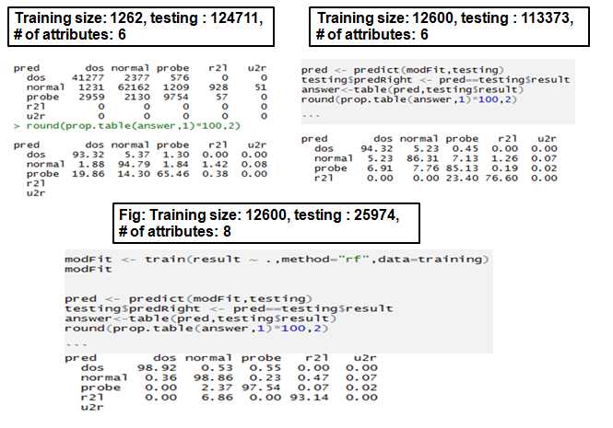

8.4 Types of testing performed
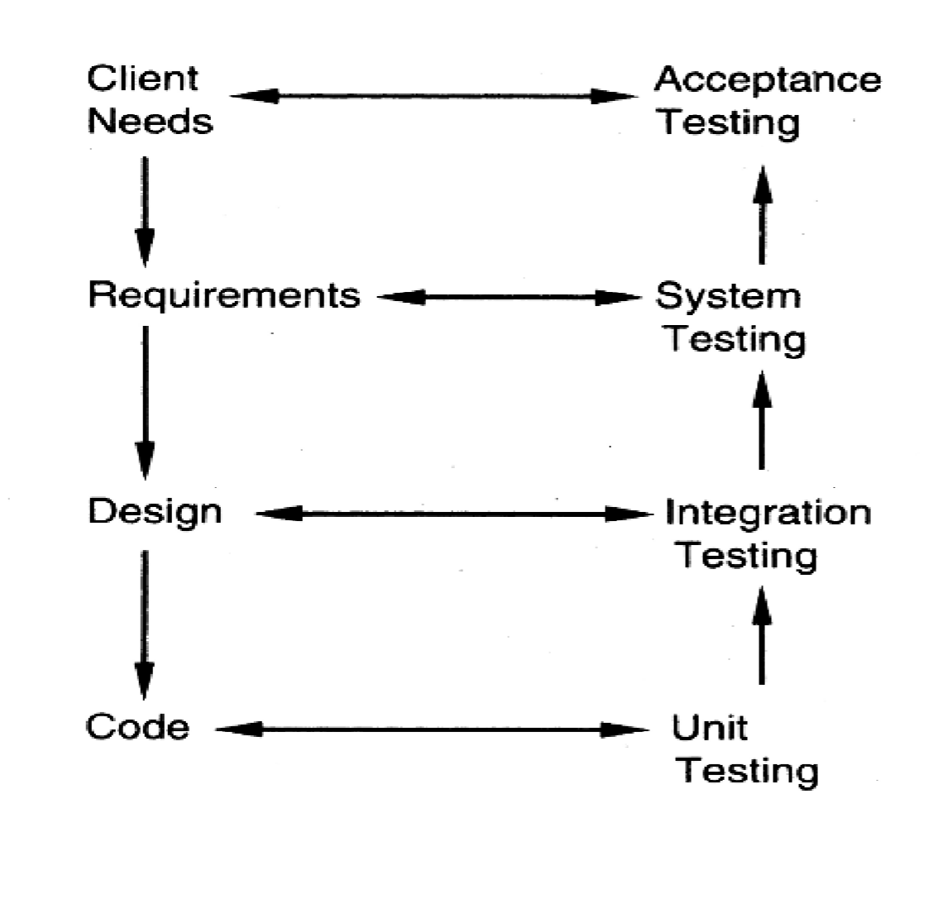
Figure 8.1 Types of testing

8.5 Conclusion
The test cases were executed successfully and thus the project was tested and modified accordingly when the changes were required or when test cases failed.

CHAPTER 9

9. CONCLUSION & SCOPE FOR FUTURE WORK

The product provides you with different features which essentially provide proper web application security.
We applied new combinations of distance metrics and learning models and there is existed a few anomalies and false predications. This can be attributed to the problem of over fiiting the data onto the model. But some of the models out-performed the existing keystroke dynamic classifiers which use traditional algorithms and distance metrics

The pre-processing, construction of classifiers comparison, analysis gave us some insights. The redundancy can be eliminated by finding out the zero-variance features and not is including them in the training set as it leads to biased results.

Once threshold efficiency reached, any increase in the training set would only over-fit the data. Therefore the results would tend to deteriorate if training set is kept increasing.

CHAPTER 10
10. REFERENCES

[1] KDD Cup 1999 Data, http://kdd.ics.uci.edu/databases/kddcup99/kddcup99.html

[2] Xu, Xin. "Adaptive intrusion detection based on machine learning: feature extraction, classifier construction and sequential pattern prediction." International Journal of Web Services Practices 2, no. 1-2 (2006): 49-58.

[3] Kumar, Vipin, Himadri Chauhan, and Dheeraj Panwar. "K-means clustering approach to analyze NSL-KDD intrusion detection dataset." International Journal of Soft Computing and Engineering 3 (2013).

[4] Sahu, Santosh Kumar, Sauravranjan Sarangi, and Sanjaya Kumar Jena. "A detail analysis on intrusion detection datasets." In Advance Computing Conference (IACC), 2014 IEEE International, pp. 1348-1353. IEEE, 2014.

[5] Ganame, Abdoul Karim, Julien Bourgeois, Renaud Bidou, and Francois Spies. "A global security architecture for intrusion detection on computer networks." computers & security 27, no. 1 (2008): 30-47.

[6] Boukerche, Azzedine, Kathia Regina Lemos Jucá, João Bosco Sobral, and Mirela Sechi Moretti Annoni Notare. "An artificial immune based intrusion detection model for computer and telecommunication systems." Parallel Computing 30, no. 5 (2004): 629-646.

[7] Mahmood, Abdun Naser, Christopher Leckie, and Parampalli Udaya. "An efficient clustering scheme to exploit hierarchical data in network traffic analysis." IEEE Transactions on Knowledge and Data Engineering 20, no. 6 (2008): 752-767.

[8] Ajith Abraham, Ravi Jain, Johnson Thomas and Sang Yong Han, “D-SCIDS: Distributed soft computing intrusion detection system”, Elsevier, Journal of Network and Computer Applications, Vol.30, No.1, pp. 81–98, 2007..

[9]L. C. F. Ara´ujo, L. H. R. Sucupira, M. G. Liz´arraga, L. L. Ling, and J. B. T. Yabu-uti. . “User authentication through typing biometrics features”, In Proc. 1st Int’l Conf. on Biometric Authentication (ICBA), volume 3071 of Lecture Notes in Computer Science, pp. 694–700, 2004.

[10] F. Bergadano, D. Gunetti, and C. Picardi, “User Authentication through Keystroke Dynamics”, ACM Trans. Information and System Security, 5(4), pp. 367–397, 2002.

[11] S. Cho, C. Han, D. H. Han, and H. Kim. “Web-based keystroke dynamics identity verification using neural network”, Journal of Organizational Computing and Electronic Commerce, 10(4):295–307, 2000.

[12] Yu Zong and Yunbin Deng, Anil K Jain, “Keystroke Dynamics for User Authentication”, Int’l Joint Conf. on Biometrics (IJCB), pp. 1-5, 2011.

[13] Leggett, John, and Glen Williams. "Verifying identity via keystroke characterstics." International Journal of Man-Machine Studies 28, no. 1 (1988): 67-76.

[14] Killourhy, Kevin S., and Roy A. Maxion. "Comparing anomaly-detection algorithms for keystroke dynamics." In Dependable Systems & Networks, 2009. DSN'09. IEEE/IFIP International Conference on, pp. 125-134. IEEE, 2009.
[15] Joyce, Rick, and Gopal Gupta. "Identity authentication based on keystroke latencies." Communications of the ACM 33, no. 2 (1990): 168-176.

[16] Killourhy, Kevin S., and Roy A. Maxion. "Comparing anomaly-detection algorithms for keystroke dynamics." In Dependable Systems & Networks, 2009. DSN'09. IEEE/IFIP International Conference on, pp. 125-134. IEEE, 2009.

Appendix

DOWNLOAD INSTRUCTIONS

You can use/ contribute to the project by either downloading form out live project or cloning from our repository. The set up instructions are as below:
Clone the repository into you working directory using the command
git clone https://github.com/deepakjayaprakash/Alcatraz.git
or
you can also fork into your own repository by the command
git fork https://github.com/deepakjayaprakash/Alcatraz.git
or you can click the below link and directly download as zipped folder by clicking the link below:
Setting up the workspace and contributing!
After using any one download option copy paste the directory in you XAMPP/WAMPP or any local host directory that you use to run your server appications
To work any one of the features, use the following files
1. Keystroke Authentication: /keystroke.html,/keystroke_demo.php, /profile.php, /check_login.php, /register.php, /logout.php, /validate.php
2.Network Intrusion Detection: /nid_index.html, /nid_demo.php
3.Anti-Keylogging: /form1.php, /B_Auth.php, /antikeyloggin.html, /output_encoded.php, /antikey.php
4. A-Auth:/auth.php, /auth_register.php, /auth_login.php, /auth_profile.php,/auth_register.php

SCREEN SNAPSHOTS

